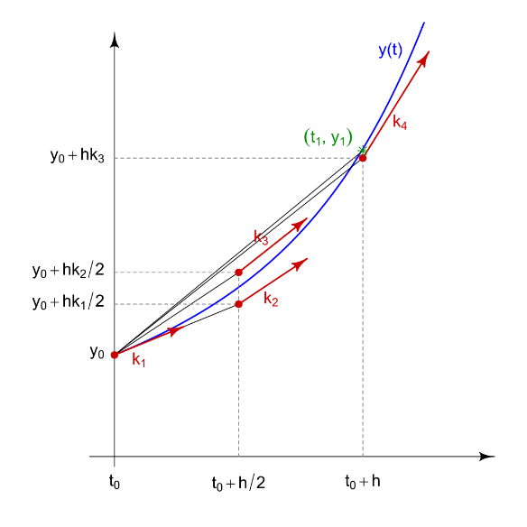

**TECHNIQUES OF NUMERICAL INTEGRATION**

**With Application to the Calculation of Stellar Interiors**

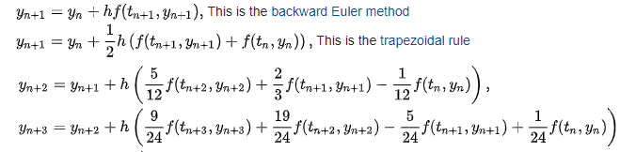

**PREFACE**

This paper is the second in a series of three devoted to the subject of the calculation of the structure of stars. The first paper looks at the physics of stellar structures. This paper looks at numerical integration of mathematical functions since the physics is centred around a set of coupled differential equations that need to be integrated. It sets out some of the techniques of numerical integration. The third paper will combine the first two and uses techniques of numerical integration to solve the equations for stellar structure. The third paper contains full C++ code for solving the problem.

**Contents**

**1.** **INTRODUCTION** 7

**2.** **THE CALCULATION OF DERIVATIVES** 8

**3.** **THE CALCULATION OF INTEGRALS** 10

3.1 The Fundamental Theorem Of Calculus 10

3.1.1 Area Under the Curve of a Function 10

3.1.2 Differentiating the Area Function 11

3.2 Classical Analytic Integration Techniques 12

3.2.1 Integration by Partial Fraction 12

3.2.2 Integration by Substitution 13

3.2.3 Integration by Parts 14

3.2.4 Integration Using Trigonometric Substitution 15

3.3 Integrals for Which There is No Known Analytic Solution 18

**4.** **DIFFERENTIAL EQUATIONS IN PHYSICS** 19

4.1 A Falling Mass with Air Resistance and Spring Force 19

4.2 Air Pressure At a Height and with Varying Air Temperature 19

4.3 Deflections of a Beam 22

4.4 The Classical Wave Equation 24

**5.** **TAYLOR SERIES SOLUTIONS** 26

5.1 Taylor Series Expansions 26

5.2 Use in Ordinary Differential Equations 29

5.3 Limitations of Taylor/Maclaurin Series 30

5.3.1 Radius of Convergence 30

5.3.2 Maclaurin Series May Have Undefined Function and/or Derivatives 31

5.3.3 Error Bounds 32

**6.** **NUMERICAL INTEGRATION** 34

6.1 The Classification of Differential Equations in Mathematics 34

6.2 First Order Ordinary Differential Equations 35

6.2.1 First Step : Euler’s Method 38

6.2.1.1 The Forward Euler Method 38

6.2.1.2 The Backward Euler Method 39

6.2.1.3 The Heun Method 43

6.2.1.4 Variations on the Euler Theme 45

6.2.2 Second Step : Runge-Kutta Methods 45

6.2.2.1 Explicit Runge-Kutta Methods 45

6.2.2.2 Implicit Runge-Kutta Methods 49

6.2.2.3 Guassian Quadrature 50

6.2.3 Third Step : Adams-Bashforth Methods 51

6.2.4 Fourth Step : Adams-Moulton Methods 58

6.3 The Calculation of Error Bounds in Numerical Integration 59

6.3.1 Error Bounds for Non-Taylor Series Integrations 59

6.4 Difference Tables 59

6.4.1 Difference Tables and Adams-Bashforth Methods 59

6.4.2 Standard Extrapolation 59

6.4.3 An Example Ordinary Differential Equation 61

6.4.4 Schwarszchild’s Use of Difference Tables 63

**7.** **COUPLED DIFFERENTIAL EQUATIONS** 64

6.1 Definition of Coupled Equations 64

**Figure 1: Definition of a Derivative** 8

# 

# **INTRODUCTION**

I am aiming this paper at readers who perhaps have a good mathematical knowledge but whose knowledge stops just short of calculus or at the beginning of calculus. If it sometimes seems too simple please bear this in mind. I find some of it simple but other parts quite difficult to understand. Differentiation is simple, integration needs a bit more imagination. Taylor and Maclaurin expansions are quite easy to understand but polynomial interpolation for multistep numerical integration begins to get quite challenging.

The first two sections of this paper are a sort of revision of what many readers probably already know, although I have included the classic method of calculating derivatives and a perhaps novel way of looking more fundamentally at integration through The Fundamental Theorem of Calculus. This gives a more thorough grounding to understanding integration instead of just thinking of integration as the reverse of differentiation.

This paper cannot cover all the issues around differentiation and integration and not, in particular, the many different ways of getting analytic solutions to integrals. These two subjects alone need several books to cover them. However, I have included some examples of analytical integration in section 3. For the rest, I have included many references to text or video sources which give what I consider to be the best explanations of different subjects. This is where the value of this paper lies : I have sifted the available sources and selected what I consider to be the best explanations, in terms of omitting unnecessary mathematical complexity and, in the case of videos, the best graphics. This paper *concentrates the best resources available on the internet.*

The problem of the calculation of stellar structures at the point where the physics becomes pure mathematics is the problem of integrating a set of derivatives. Sometimes a derivative can be integrated analytically. Often, however, it cannot, since no analytic solution is known or possible. Section 4, therefore, is where most of this paper occurs.

I have not bothered to put all the equations in a uniform type since a screen grab or photograph is probably better anyway. So the figures are a pot pourri of written text, print characters and graphs, depending on the author. All sources are acknowledged.

# **THE CALCULATION OF DERIVATIVES**

Figure 1 gives the standard geometrical illustration of the definition of a derivative ${dy}/{dx}$ of a function $f(x)$ of the single independent variable $x$. The derivative at the point A at $x_{0}$ is derived first by taking a point B at $\left(x_{0}+δx\right)$ and defining :

$\frac{δy}{δx}$ = $\frac{f\left(x_{0}+δx\right)-f(x_{0})}{δx}$

and then the derivative at A is obtained by moving B progressively closer to A whereupon ${δy}/{δx }$ becomes ${dy}/{dx}$ :

$\frac{dy}{dx}$ = $\lim_{δx→0}\left(\frac{δy}{δx}\right)$

In the limit the tangent line at A, the line AC in the figure, is related to the derivative through the angle α because the tangent of α is the change in $y$ divided by the change in $x$.

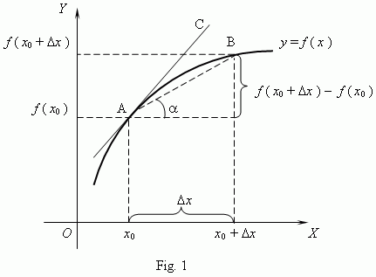

**Figure 1: Definition of a Derivative**

**Source :** [Mathematics Stack Exchange](https://math.stackexchange.com/questions/12287/approaching-to-zero-but-not-equal-to-zero-then-why-do-the-points-get-overlappe)

The derivative can be computed for each $f(x)$ by simple algebra (usually). As an example, take = :

= **2**  = + +

– = + + - = +

= = +

and in the limit :

$\frac{dy}{dx}$ = $2x_{0}$

# **THE CALCULATION OF INTEGRALS**

The last section described the classic way of calculating derivatives. The proof that the integral of the derivative is the original function is less often demonstrated. The Fundamental Theorem of Calculus shows that this is the case.

## The Fundamental Theorem Of Calculus

This section gives a geometrical proof, for a function of a single variable, that the integral of the derivative of the function is the original function. The first part shows that the integral of a function is the area under the curve of the function. The second part takes the derivative of the area and recovers the original function.

### Area Under the Curve of a Function

Figure 2 shows the area under a curve being approximated by a series of rectangles. Each rectangle has an area of $v.δt$ where $v$ is the velocity read from the right-hand axis and $δt$ is the width of the base of the rectangle (one second in the figure). The sum of the areas of the rectangles :

$A=$ $\sum{v.δt}$

is an approximation to the area under the curve.

This is obviously not a good approximation. However, if the time intervals $δt$ are made smaller, the approximation gets better until, eventually, the integral :

$$A= \int{v.dt}$$

i.e the sum when the finite $δt$ is shrunk to the infinitesimal $dt$, is the area under the curve (when some start and end values of $t$ are applied).

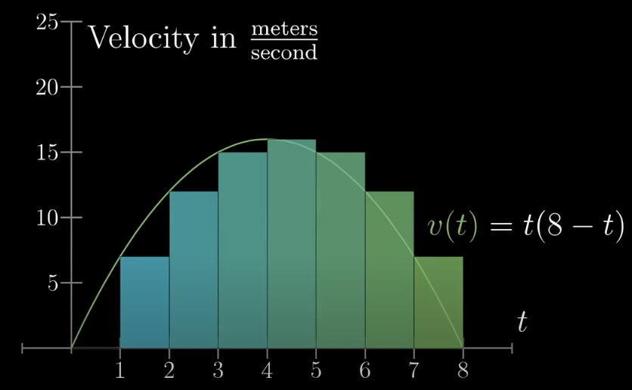

**Figure 2 : Area Under A Curve**

**Source : 3Blue1Brown,** [Integration and the fundamental theorem of calculus](https://www.youtube.com/watch?v=rfG8ce4nNh0)

### Differentiating the Area Function

Knowing the definition of a derivative and the interpretation of an integral as the area under a curve enables a geometrical construction of the fundamental theorem of calculus. This, put qualitatively, asks how, given a derivative, do we regain the original function.

Differentiating the area integral derived above is a simple way to demonstrate the fundamental theorem. In figure 3, where $A(x)$ or $y(x)$ is the integral of $f(x)$, one can see the direction of the proof.

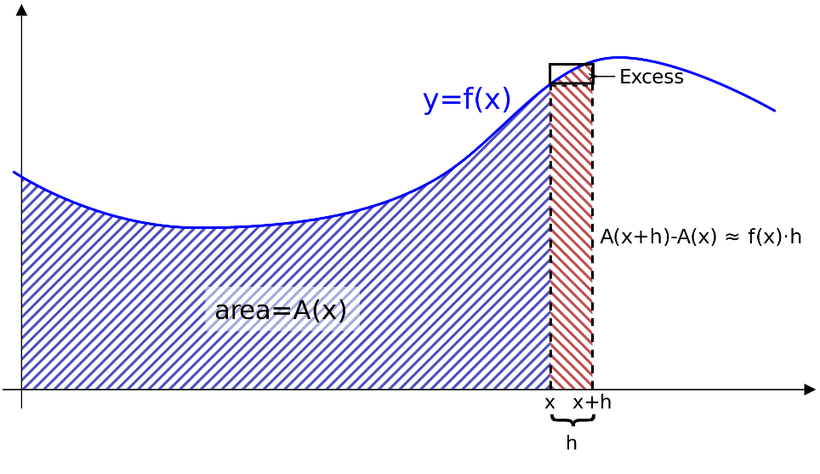

**Figure 3 : Differentiating the Area Integral**

**Source :** [Fundamental theorem of calculus - Wikipedia](https://en.wikipedia.org/wiki/Fundamental_theorem_of_calculus#cite_note-6)

Basically,

$A=\int{f\left(x\right)dx}$

$δA \sim f(x)$. $δx$

$$\frac{δA}{δx} \sim f(x)$$

$\frac{d}{dx} \left[\int{f\left(x\right)dx}\right]=f(x)$

In other words, the integral of the derivative is the $y$ in $dy/dx$. The proof is more fully developed in the reference.

## Classical Analytic Integration Techniques

There are a number of set techniques for integrating equations. Some may be familiar to readers of this paper as they are often topics for school or first year university courses. They are only mentioned here for completeness and as a prelude to the main topic of this paper, numerical integration, where there is no known solution *or where no function to be integrated is known, only a set of discrete values*. Note the second situation where numerical integration might be used – this could occur, perhaps, in software systems where a sensor is measuring an external value at a regular interval.

The video [**https://www.youtube.com/watch?v=KIRRxmxw4b4**](https://www.youtube.com/watch?v=KIRRxmxw4b4)succinctly explains the common techniques of integration and discusses which techniques to choose for a particular problem. There are abundant resources on analytical integration, in books and in videos, so in the subsections below only the most basic examples are given just to describe the principle of each technique. Here below are three good online sites discussing techniques of integration.

[**7: Techniques of Integration - Mathematics LibreTexts**](https://math.libretexts.org/Bookshelves/Calculus/Book%3A_Calculus_(OpenStax)/07%3A_Techniques_of_Integration)

[**calculus-dvips.dvi (whitman.edu)**](https://www.whitman.edu/mathematics/calculus/calculus_08_Techniques_of_Integration.pdf)

[**Techniques of Integration | Boundless Calculus (lumenlearning.com)**](https://courses.lumenlearning.com/boundless-calculus/chapter/techniques-of-integration/)

The work below draws greatly on the LibreTexts material created by the OpenStax technology initiative referenced in the link above.

### Integration by Partial Fraction

Partial fractions are the fractions produced when a more complex fraction is split into components. For, example, the source [**Partial Fractions (mathsisfun.com)**](https://www.mathsisfun.com/algebra/partial-fractions.html)shows how the fraction :

$$\frac{5x-4}{x^{2}-x-2}$$

can be factored :

$$x^{2}-x-2=(x-2)(x+1)$$

and then :

$\frac{5x-4}{x^{2}-x-2}$ = $\frac{2}{x-2} + \frac{3}{x+1}$

Hence, the integral :

$$\int{\frac{5x-4 }{x^{2}-x-2}dx}$$

for which a solution is not immediately apparent, becomes :

$$\int{\frac{2}{x-2}dx+\int{\frac{3}{x+1}dx}}$$

which, using the integral of $c/{(ax+b)}$ as given in [**Lists of integrals - Wikipedia**](https://en.wikipedia.org/wiki/Lists_of_integrals)leads to :

$$\int{\frac{5x-4}{x^{2}-x-2}dx}=2\ln\left(x-2\right)+3ln⁡(x+1)$$

The conversion to partial fractions above is particularly simple since the denominator can be immediately factored. There are more complex denominators that are harder to factor and some which cannot be completely factored.

### Integration by Substitution

The source [**https://www.youtube.com/watch?v=KIRRxmxw4b4**](https://www.youtube.com/watch?v=KIRRxmxw4b4)shows a simple case of integration by substitution which makes a substitution and then uses partial fractions as in the previous example. The integral :

$$\int{\frac{(1+e^{x})}{(1- e^{x})}dx}$$

can be re-arranged by making the substitution ${u= e}^{x}$. Now the $dx$ must be changed into a $du$. This can be done by using :

$$dx= \frac{dx}{du}du$$

and since $\ln{u=x}$ then :

$$\frac{dx}{du}= \frac{d}{du}(\ln{u)= \frac{1}{u}}$$

So the integral has now become :

$$\int{\frac{(1+u)}{u(1-u)}du}$$

which can now be split into partial fractions :

$$\int{\frac{1}{u}du}+ \int{\frac{2}{(1-u)}du}$$

which can then be integrated to :

$\ln{u-2*ln⁡(1-u)}$

and then back-substituting with the original substitution gives :

$$x-2*ln⁡(1-e^{x})$$

### Integration by Parts

The explanation and demonstration of integration by parts in [**7.1: Integration by Parts - Mathematics LibreTexts**](https://math.libretexts.org/Bookshelves/Calculus/Book%3A_Calculus_(OpenStax)/07%3A_Techniques_of_Integration/7.1%3A_Integration_by_Parts)(license CC-BY-SA-NC 4.0) is below reproduced as it is so clear.

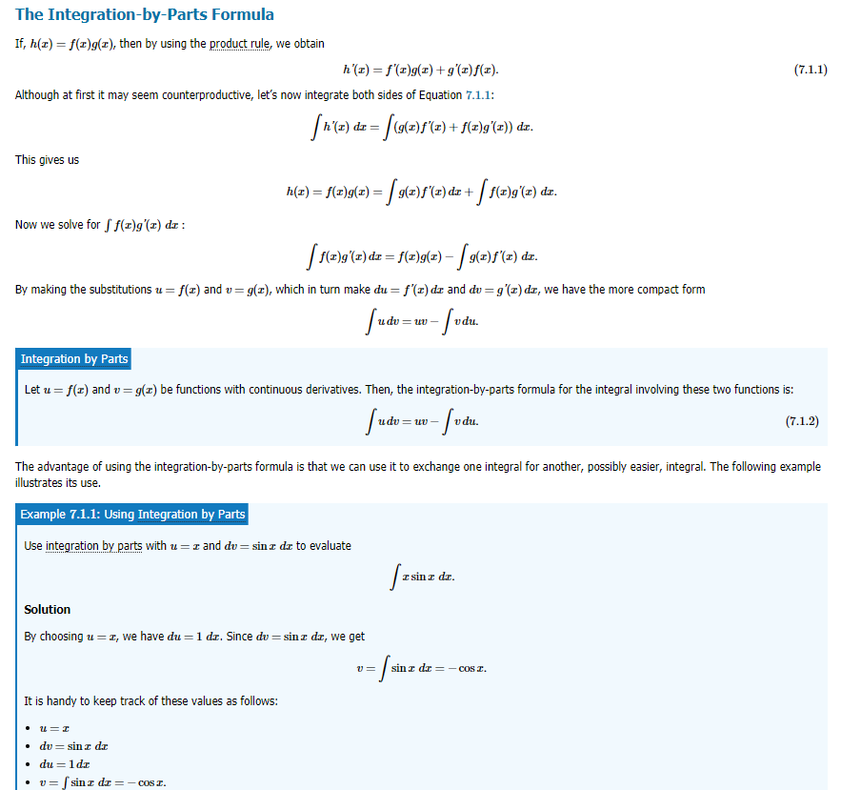

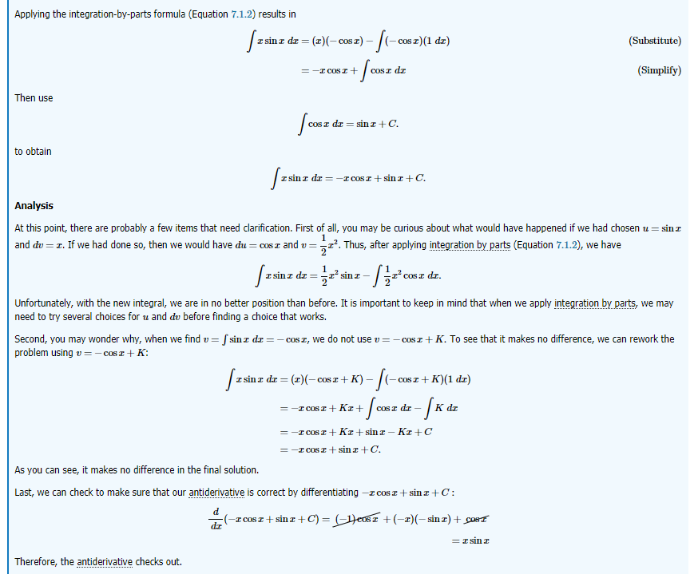

**Figure 4 : Integration by Parts**

**Source :** [**7.1: Integration by Parts - Mathematics LibreTexts**](https://math.libretexts.org/Bookshelves/Calculus/Book%3A_Calculus_(OpenStax)/07%3A_Techniques_of_Integration/7.1%3A_Integration_by_Parts)

### Integration Using Trigonometric Substitution

This technique is useful for integrating what one might colloquially call “awkward” structures such as :

$\sqrt{a^{2}- x^{2}}$ or $\sqrt{a^{2}+ x^{2}}$ or $\sqrt{x^{2}- a^{2}}$

The technique has two stages, both of which are substitutions. The first stage basically relies on the trigonometric identity :

$$\sin^{2}θ + \cos^{2}θ = 1$$

By substituting $x$ with a function of $θ$ the awkward square root can be removed. The resulting integral of a product of sines and cosines of $θ$ can then be integrated using a further substitution. For example take a case of $\sqrt{a^{2}- x^{2}}$:

$$\int{\sqrt{9- x^{2}} dx}$$

Using $x=a\sin{θ}$ and therefore :

$$dx= \frac{dx}{dθ}dθ$$

and :

$$dx=3cosθdθ$$

$$\int{\sqrt{9- 9\sin^{2}θ } 3cosθ dθ}$$

$$\int{3\sqrt{1- \sin^{2}θ } 3cosθ dθ}$$

$$\int{3cosθ.3cosθ dθ}$$

$$\int{9\cos^{2}θ dθ}$$

The integral has now lost the difficult square root but is now in a simplified form. However, a second step is now needed to solve the trigonometric integral. This calls on a technique to solve the general form :

$$\int{\cos^{j}x.\sin^{k}x dx}$$

where $k$ can be $0$. As an example of the more general case take :

$$\int{\cos^{2}x.\sin^{3}x} dx$$

and rewrite it as :

$$\int{\cos^{2}x.\sin^{2}x.\sin{x}} dx$$

and then write the $\sin^{2}x$ as $\left(1-\cos^{2}x\right)$ so that the integral becomes :

$$\int{\cos^{2}x.\left(1-\cos^{2}x\right).\sin{x}} dx$$

Then make the substitution $u=\cos{x}$. This leads to :

$$\int{{- u}^{2}\left(1-u^{2}\right)} du$$

which is :

$$\int{\left(u^{4}-u^{2}\right)} du$$

which integrates to :

$$\frac{1}{5}u^{5}- \frac{1}{3}u^{3}+C$$

Or, on back-substitution :

$$\frac{1}{5}\cos^{5}x- \frac{1}{3}\cos^{3}x+C$$

Returning to the specific example above, where $k$ is $0$:

$$\int{9\cos^{2}θ dθ}$$

the trigonometric identity :

$$\cos^{2}θ= \frac{1}{2}+\frac{1}{2}cos2θ$$

is used, and therefore gives :

$$\int{9(\frac{1}{2}+\frac{1}{2}cos2θ) dθ}$$

which is :

$$\frac{9}{2}θ+\frac{9}{4}sin2θ+C$$

$$\frac{9}{2}θ+\frac{9}{2}sinθcosθ+C$$

Then using the triangle :

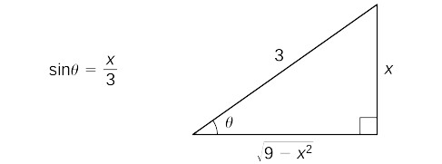

and the inverse sine, one gets :

$$\frac{9}{2}\sin^{-1}\left(\frac{x}{a}\right)+\frac{9}{2}.\frac{x}{3}.\frac{\sqrt{9-x^{2}}}{3}+C$$

$$\frac{9}{2}\sin^{-1}\left(\frac{x}{a}\right)+\frac{x\sqrt{9-x^{2}}}{2}+C$$

There are similar standard substitutions for the case of $\sqrt{a^{2}+ x^{2}}$ which involve using $x=a\tan{θ }$ and the change of the infinitesmal as :

$$dx=a\sec^{2}θdθ$$

This then leads to :

$\sqrt{a^{2}+ x^{2}}$ = $asecθ$

which can be solved using the second substitution for solving the general integral :

$$\int{\tan^{j}x.\sec^{k}x dx}$$

See the main reference [7.2: Trigonometric Integrals - Mathematics LibreTexts](https://math.libretexts.org/Bookshelves/Calculus/Book%3A_Calculus_(OpenStax)/07%3A_Techniques_of_Integration/7.2%3A_Trigonometric_Integrals) for fuller details.

## Integrals for Which There is No Known Analytic Solution

Some functions have no known analytic solution, such as, surprisingly :

$$\int{e^{-x^{2}}dx}$$

The term “analytic solution” is used here to indicate an indefinite integral. Solutions may exist for definite integrals. For the case above :

$$\int_{0}^{∞}{e^{-x^{2}}dx=\frac{\sqrt{π}}{2}}$$

See [Lists of integrals - Wikipedia](https://en.wikipedia.org/wiki/Lists_of_integrals) for more examples.

# **DIFFERENTIAL EQUATIONS IN PHYSICS**

Differential equations are ubiquitous in physics. Not because they are designed to be differential equations but because the most basic laws of physics when applied to many physical situations naturally give rise to differential equations. Below are some examples that demonstrate how this happens. The first three are what might be called applied physics – in some ways rather humdrum physical problems. These are problems in what is sometimes called mechanics. The last two are from pure physics and involve the macroscopic world.

## A Falling Mass with Air Resistance and Spring Force

One of the most well-known equations in physics is Newton’s law about acceleration and force :

$$m\frac{d^{2}x}{dt^{2}} = F$$

where $x$ is position (in one dimension), $t$ is time, and $F$ is the force acting on the mass $m$. If the specific situation involved a mass $m$ falling under gravity the equation becomes :

$$m\frac{d^{2}x}{dt^{2}} = -mg$$

but if there is another force due to air resistance which is proportional to the velocity of the mass then :

$$m\frac{d^{2}x}{dt^{2}} = -mg -k\frac{dx}{dt}$$

where $k$ is a constant. If, additionally, the mass is attached to a spring and Hooke’s law applies then :

$$m\frac{d^{2}x}{dt^{2}} = -mg -k\frac{dx}{dt} -cx$$

where $c$ is another constant. So even a simple problem has produced a fairly complex equation. The key issue is that the air resistance is proportional to the velocity and that the introduction of this term into the analysis turns a simple differential equation into a more complex equation, the solution to which is not clear.

## Air Pressure At a Height and with Varying Air Temperature

The example in the diagram below finds that the pressure $p$ at a height $y$ is, to a first approximation :

$$\frac{dp}{dy}= -ρ\left(y\right)g$$

where $ρ(y)$ is the density of the air at height $y$. The equation of state for ideal gases when blended in leads to :

$$\frac{dp}{dy}= -\frac{Mg}{RT}p$$

which integrates to :

$$p\left(y\right)=p_{0}e^{\frac{Mg}{RT}y}$$

Taking into account the decrease of temperature with height leads to a modified initial equation :

$$\frac{dp}{dy}= -\frac{Mg}{R(293-\frac{y}{200})}p$$

which can be integrated to :

$$p\left(y\right)=p_{0}(1-βy)^{\frac{Mg}{293Rβ}}$$

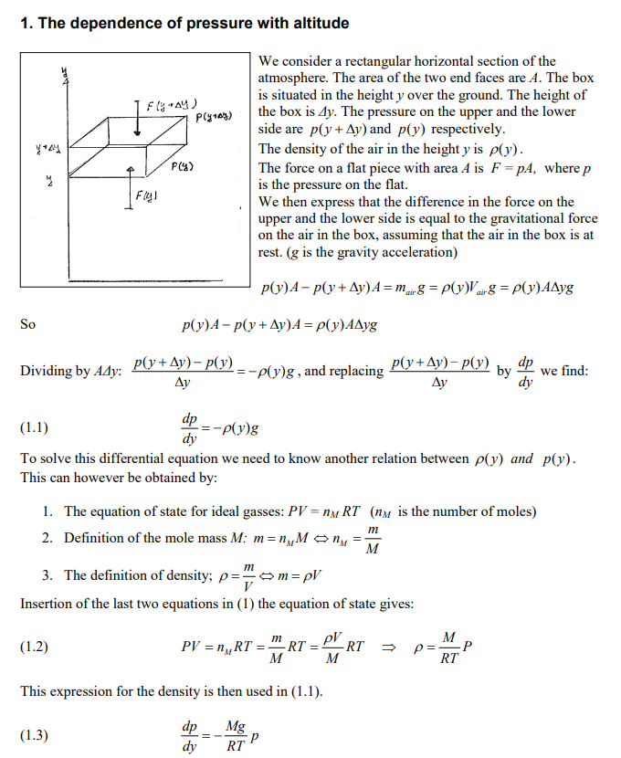

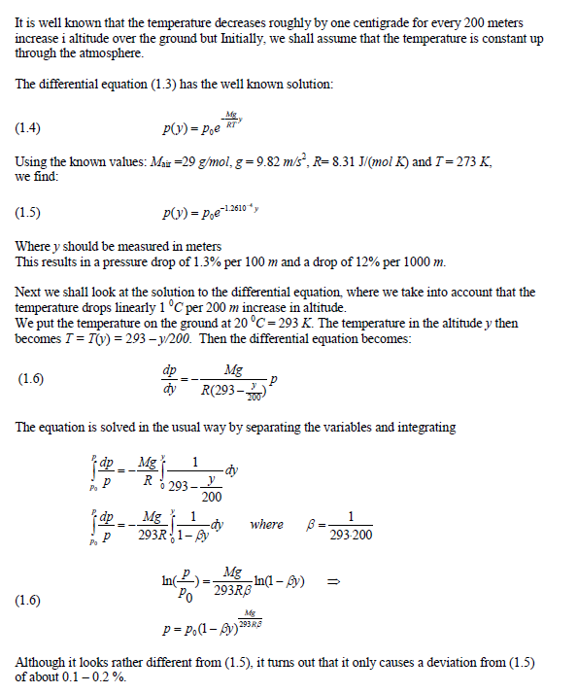

**Figure 5 : Variation of Air Pressure with Altitude**

**Source for the above :** [**Differential_equations_of_physics.doc (olewitthansen.dk)**](http://www.olewitthansen.dk/Physics/differential_equations_of_physics.pdf)

## Deflections of a Beam

The problem described below is a case study from Numerical Methods With Fortran IV Case Studies by Dorn and McCracken (1967). The case study concerns a cantilever beam (see [**https://skyciv.com/docs/tutorials/beam-tutorials/cantilever-beam/**](https://skyciv.com/docs/tutorials/beam-tutorials/cantilever-beam/)**).** L is the length of the beam. P is a load at the free end of the beam. Variable $x$ is the distance along the beam with $x=0$ at the built-in end. Variable $y$ is the downward deflection of the beam along $x$. This situation gives rise to a second order non-linear differential equation.

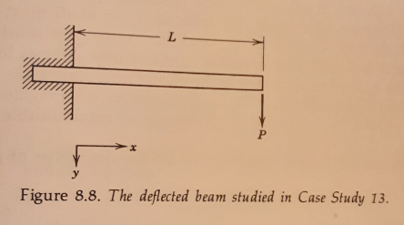

**Figure 6 : Downward Deflection of a Cantilever Beam Under a Load**

If $E$ is the Young’s modulus of the material and $I$ is the moment of inertia of the cross-section of the beam about a line a line through the centre of mass of the cross-section and perpendicular to both the $x$ and $y$ directions then, for elastic deflections :

$$\frac{y''}{[1+(y^{'})^{2}]^{\frac{3}{2}}}=\frac{P(L-x)}{EI}$$

with the boundary conditions due to deflection and slope at $x=0$ necessarily being zero :

$y\left(0\right)=0$

$y^{'}\left(0\right)=0$

In many cases $y^{'}$ may be small enough compared to 1 to neglect, in which case the resulting expression :

$$y''=\frac{P(L-x)}{EI}$$

is easily integrated to :

$y\left(x\right)=\frac{P}{6EI}x^{2}(3L-x)$

If the $y^{'}$ value cannot be neglected then the equation can only be solved numerically.

## The Classical Wave Equation

This equation, usually formulated in the form of a vibrating string or wire, relies on a deft equating of a time derivative and a spatial derivative and eventually results in a solution consisting of a superposition of sine and cosine waves. Figure 7 below presents the problem.

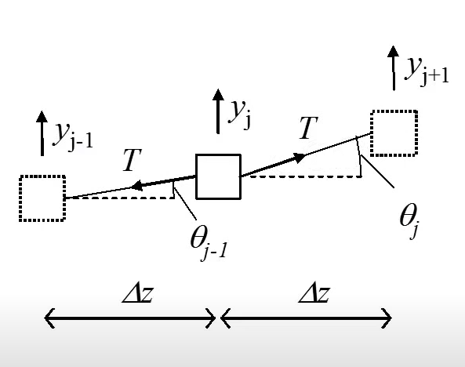

**Figure 7 : Framing the Problem of the Classical Wave Equation**

The middle square represents a small segment of a string, under a force T on the right whose vertical component is pulling it up and the same force on the left whose vertical component is pulling it down. The vertical axis is $y$ and the horizontal axis is $z$. The force on the right pulling the segment of mass $m$ up is $Tsinθ_{j }$ and the corresponding force on the left is $Tsinθ_{j-1}$. The net force on the mass m is :

$F_{j}=T(sinθ_{j+1 }- sinθ_{j})$

For small $θ$, sin $θ$ is approximately tan $θ$, so :

$F_{j }\sim$ $T(tanθ_{j+1 }- tanθ_{j})$

$F_{j} \sim T(\frac{y_{j+1}-y_{j}}{∆z}- \frac{y_{j}-y_{j-1}}{∆z})$

since $\frac{(\frac{y_{j+1}-y_{j}}{∆z}- \frac{y_{j}-y_{j-1}}{∆z})}{∆z}$ $\sim \frac{d^{2}y}{{dz}^{2}}$

then $F_{j} \sim T∆z\frac{d^{2}y}{{dz}^{2}}$

But at the same time, from Newton’s law :

$F_{j} \sim m\frac{d^{2}y}{{dt}^{2}}$

Given that $m$ can be expressed as $ρ∆z$ where $ρ$ is a linear density, then

$ρ∆z\frac{d^{2}y}{{dt}^{2}}$ = $T∆z\frac{d^{2}y}{{dz}^{2}}$

$\frac{d^{2}y}{{dz}^{2}}$ = $\frac{ρ}{T}\frac{d^{2}y}{{dt}^{2}}$

The solution of this equation is described in the series of videos starting at [Quantum Mechanics- Classical Wave Equation & Separation of Variables (1/9) - YouTube](https://www.youtube.com/watch?v=8Lr0vRrQOqo).

The more general, but more difficult, analogous argument for fields, starting with the Laplacian operator, is described here [Quantum Mechanics 5a - Schrödinger Equation I - YouTube](https://www.youtube.com/watch?v=aU_bd7fku90).

# **TAYLOR SERIES SOLUTIONS**

In both this section and in the next section on numerical integration the essential problem is to calculate the “next value”. That is, we have a first order ordinary differential equation ${dy}/{dx}$ = $f\left(x, y\right)$ that is not easily integrable to $y(x)$ but for which we have one known point on $y(x)$ and we wish to calculate a point “further along” the curve of $y(x)$ i.e more to the right of the initial known point.

Taylor series enable this to be done approximately in a semi-analytic way using ${dy}/{dx}$ and the higher derivatives. Section 5 on numerical integration describes another way of getting the “next value” by using only ${dy}/{dx}$ (i.e *not* the higher derivatives) of the $y(x)$ curve at various points along the curve.

## Taylor Series Expansions

Taylor series expansions are based on the idea that any arbitrary function $f(x)$ can be approximated by a polynomial of sufficiently high degree :

$f(x)$ = $\sum_{k=0}^{k=n}{c_{k}x^{k}}$

Maclaurin series are a special case of Taylor series where the expansion point is at 0. The video referred to in Figure 6 explains this very well and shows that the number of terms of the series expansion is a matter of choice and that the nth term in the series contains the nth derivative of the function. The Taylor series definition is as in Figure 5.

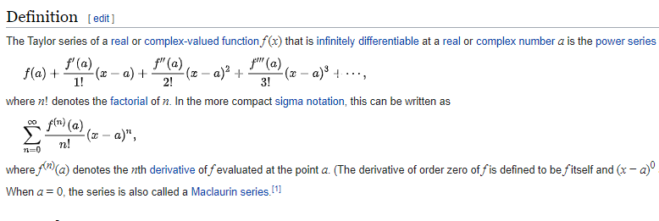

**Figure 5 : Definition of Taylor Series**

**Source :** [Taylor series - Wikipedia](https://en.wikipedia.org/wiki/Taylor_series)

The video referenced in Figure 6 below is an excellent visual demonstration of Taylor and Maclaurin series.

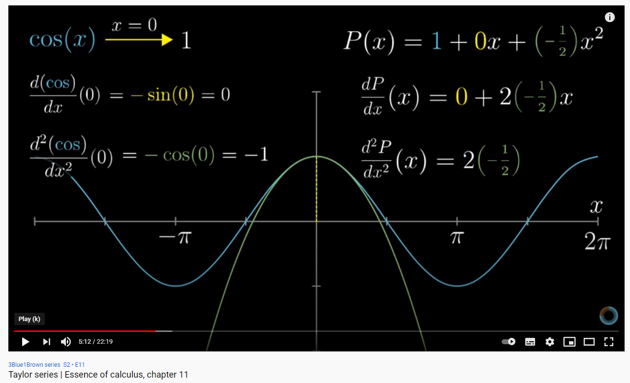

**Figure 6 : Taylor and Maclaurin Series Exp[ansions**

**Source :** [Taylor series | Essence of calculus, chapter 11 - YouTube](https://www.youtube.com/watch?v=3d6DsjIBzJ4)

The Maclaurin series expansion is easy to calculate, as in figure 7 below.

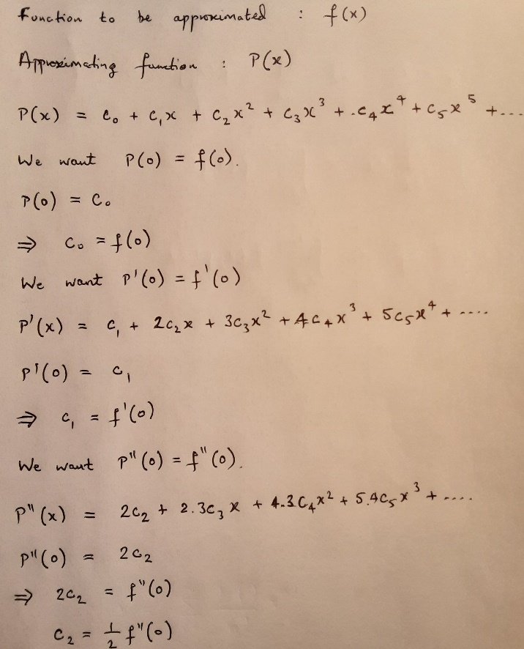

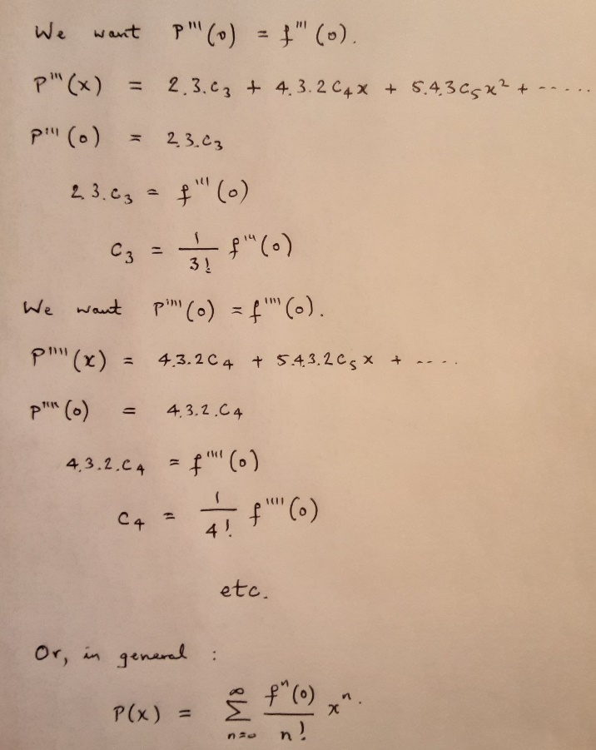

**Figure 7 : Derivation of the Maclaurin Series Coefficients**

A similar derivation is given in the source referenced at figure 8 below.

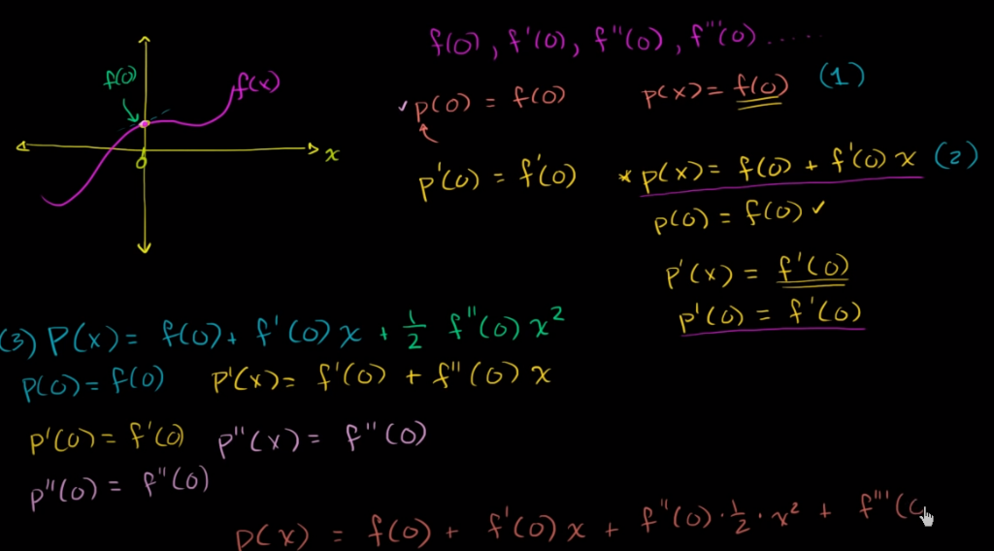

**Figure 8 : Derivation of the Maclaurin Series Coefficients**

**Source :** [Taylor & Maclaurin polynomials intro (part 1) | Series | AP Calculus BC | Khan Academy](https://www.youtube.com/watch?v=epgwuzzDHsQ)

## Use in Ordinary Differential Equations

Taylor series can be used to solve ordinary differential equations by noting that the differential equation itself gives the first derivative of the Taylor series expansion and that the higher derivatives can be derived just by differentiating the first derivative. That is, to take a simple example :

$\frac{dy}{dx}$ = $f(x, y\left(x\right))$ = $x+y+xy$ with $y\left(0\right)=1$

The Maclaurin series expansion of $y(x)$ is :

$y(x) = y(0) + y'(0)x +$ $\frac{1}{2}{y''(0)x}^{2}+\frac{1}{6}{y'''(0)x}^{3}+…$

The first term $y(0)$ is already known from the initial condition $y(0)=1$. The second term $y’(0)$ is the differential equation itself. Higher order terms can be obtained by differentiating the differential equation. Thus :

$y^{'}\left(0\right)=1$

$\frac{d^{2}y}{dx^{2}}=1+\frac{dy}{dx}+y+x\frac{dy}{dx}$

$y^{''}\left(0\right)=1+1+1+0\left(0+1+0*1\right)=3$

$y\left(x\right)=1+x+\frac{3}{2}x^{2}+…$

and so forth.

## Limitations of Taylor/Maclaurin Series

Taylor series expansions are not, however, a “magic bullet”. They are often only valid close to the point of expansion and adding more terms to the expansion does not necessarily make the answer more accurate.

### Radius of Convergence

The source [Taylor series - Wikipedia](https://en.wikipedia.org/wiki/Taylor_series) explains that Taylor series do not always converge to the value of the approximated function. The region in which they converge is known as a radius of convergence (radius because the expansions can in the general case be in the complex plane). See Figure 32 below.

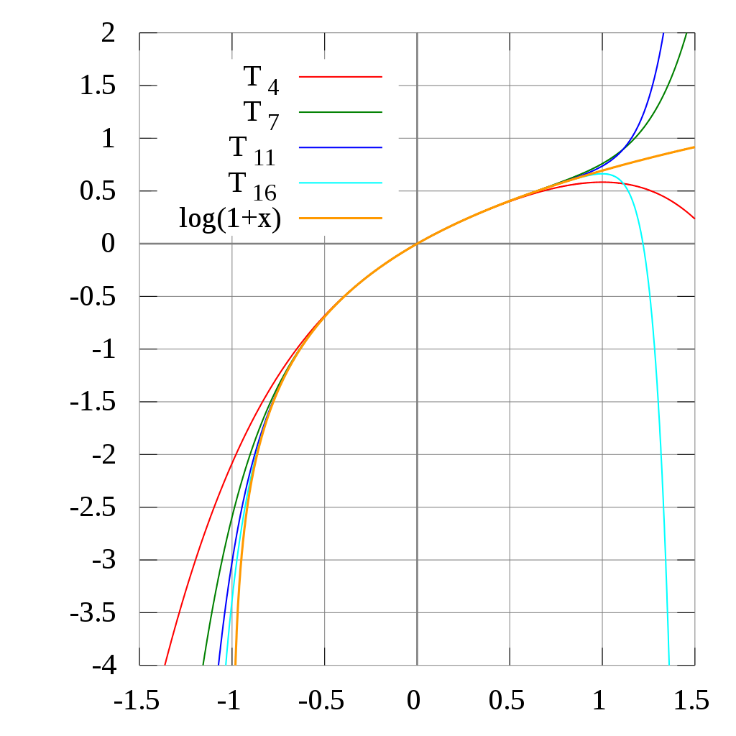

The Taylor polynomials for $ln(1 + x)$  only provide accurate approximations in the range $-1 < x ≤1.$  For $x > 1$ , Taylor polynomials of higher degree provide worse approximation.

**Figure 32 : More Terms in the Series Do Not Always Give Better Approximations**

**Source :** [Taylor series - Wikipedia](https://en.wikipedia.org/wiki/Taylor_series)

It is possible for the radius of convergence to be infinity i.e the Taylor series converges to the function for all values . Conversely, in some cases a Taylor series may converge but not to the function being approximated.

### Maclaurin Series May Have Undefined Function and/or Derivatives

Since a Maclaurin series is centred on 0, singularities often occur which mean that a Maclaurin series cannot exist. For example, the function :

$$f\left(x\right)=\frac{sin⁡(x)}{x}$$

means that $f\left(0\right)$ and all the derivatives are undefined. In this particular case, however, there is an alternative avenue for getting a series expression, since :

$\sin\left(x\right)=x-\frac{x^{3}}{3!}+\frac{x^{5}}{5!}-…$

so that :

$\frac{sin⁡(x)}{x}=1-\frac{x^{2}}{3!}+\frac{x^{4}}{5!}-…$

and $f\left(0\right)=1$.

Other cases of undefined terms that lead to the lack of a Maclaurin expansion are :

$f\left(x\right)=arcsin⁡(x-1)$

$f\left(x\right)= x^{π}$

$f\left(x\right)=\log{x}$

$f\left(x\right)=\cot{x}$

The singularity that occurs when a denominator goes to zero is potentially relevant for two of the four stellar structure equations described in section 7:

$$\frac{dP}{dr} = - ρ(P, T) \frac{GM_{r}}{r^{2}}$$

$$\frac{dT}{dr} = \frac{-3}{4ac}.\frac{χρ(P, T)}{T^{3}}.\frac{L_{r}}{4πr^{2}}$$

The $1/{r^{2}}$ term *might* be a problem. This is not necessarily so because there are other terms, such as the density $ρ(P, T)$ which might remove any singularity. Given that the overall stellar structure is to be found from numerical integration and that the first step in the solution might be a Maclaurin series expansion from the stellar centre, this could be a problem.

### Error Bounds

The text below gives a way to calculate the maximum error due to truncation of a Taylor or Maclaurin series at a given term. The source is cited below the figure.

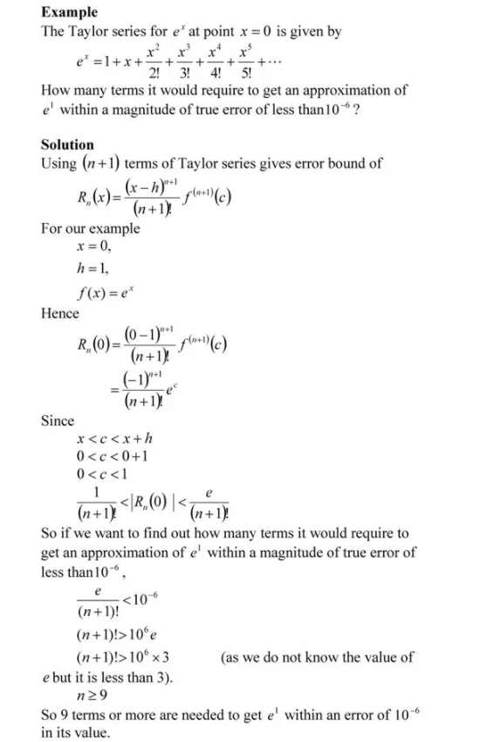

**Figure 9 : Bounds on the Potential Errors in a Series Expansion**

**Source :** [Taylor Series – The Numerical Methods Guy (autarkaw.org)](https://autarkaw.org/category/taylor-series/)

In the example above, the error bounds increase by $e$ each time $h$ is incremented i.e the further away from the point of expansion, the greater the possible error.

# **NUMERICAL INTEGRATION**

## 6.1 The Classification of Differential Equations in Mathematics

The equations in this subsection will be written as $y$ being a function of $x.$ A first order linear ordinary differential equation involves only the first derivative of $y$ with respect to $x$, no higher derivatives ; this makes it first order. If the equation involves the second derivative of $y$ this is a second order equation. If the equation contains on the right-hand side, with just the derivative on the left-hand side, only $y$ and no higher powers of $y$ it is linear. If the right-hand side contains powers of $y$ greater than one then it is a non-linear equation. If the equation doesn’t change when $x$ is replaced by $cx$ and $y$ is replaced by $cy,$ with $c$ a constant, then it is a homogeneous equation. So :

First order linear : $\frac{dy}{dx}=f\left(x\right)y+g(x)$

Second order linear : $\frac{d^{2}y}{dx^{2}}=f\left(x\right)y+g(x)$

First order non-linear : $\frac{dy}{dx}=f\left(x\right)y^{n}+g(x)$

An example of a first order non-linear homogeneous equation :

$$xy\frac{dy}{dx}=y^{2}-(x+y)^{2}e^{-y/x}$$

The degree of a differential equation is the power of the highest order derivative in the equation when any fractional powers (square root and so on) have been removed. The following equation is of order 2 and degree 1 :

$$3y^{2}(\frac{dy}{dx})^{3} - \frac{d^{2}y}{d^{2}x} = sin⁡(x^{2})$$

The following equation is of order 3 and degree 2 (the square root must first be removed) :

$$\sqrt{1+\frac{dy}{dx} } = \frac{d^{3}y}{dx^{3}}$$

There are some additional rules for the determination of the degree.

## 6.2 First Order Ordinary Differential Equations

When a first order differential equation is written it is often written as :

$$\frac{dy}{dx}=f(x,y)$$

The more precise form is usually :

$$\frac{dy}{dx}=f(x,y(x))$$

The dependence of $y$ on $x$ is not always shown i.e it is often assumed. There is usually one point where $x$ and $y$ are known :

for $x= x_{0}$: $y=y\left(x_{0}\right)= y_{0}$

With $t$ instead of $x$:

$$\frac{dy}{dt}=f(t,y(t))$$

for $t= t_{0}$: $y=y\left(t_{0}\right)= y_{0}$

The presentation of the derivative as a function of both t and y where y itself is dependent on $t$ might at first sight be difficult to comprehend. But notice that this is not an equation with two independent variables $y$ and $t$: $y$ is dependent on $t$. The equation does ***not*** define a function $z$ whose value is determined by independent variables $t$ and $y$– that would be a three-dimensional problem. The following two examples demonstrates the duality, one might even say deception, of the typical first order differential equation.

Suppose :

$y\left(t\right)= t^{2}+2t-½e^{t}$ (1)

then :

$\frac{dy}{dt} = 2t+2 -½e^{t} (2)$

but, from (1) :

$½e^{t}= t^{2}+2t-y$

so, from (2) :

$\frac{dy}{dt}= 2t+2 -(t^{2} + 2t-y)$

and :

$\frac{dy}{dt} = 2-t^{2}+ y$

And, as a second example, suppose :

$$y\left(t\right)= t^{3}cos⁡(2t)$$

then, using the rule for differentiating a product :

$$\frac{dy}{dt}=3t^{2}cos\left(2t\right)-2t^{3}sin⁡(2t)$$

$$\frac{dy}{dt}=3t^{2}(y/{t^{3}})-2t^{3}sin⁡(2t)$$

$$\frac{dy}{dt}=3y/t-2t^{3}sin⁡(2t)$$

$$\frac{dy}{dt}=3y/t-2(y/{\cos\left(2t\right)})sin⁡(2t)$$

$$\frac{dy}{dt}=3y/t-2ytan(2t)$$

The issue is that a physical problem may naturally be defined in what might be called a reflexive way (the derivative of a value depending on the independent variable *and the value itself* in some way), from reasoning about the physics, but the integrated solution may just be some $y(t)$. Additionally, it might be that there is no known $y(t)$ anyway in the sense that there is no analytic solution to the differential equation.

The next few sections start with the simplest method of calculating y values along a curve such as shown in figure 10, starting with the initial condition and progressing in the examples below along greater t i.e to the right of the graph.

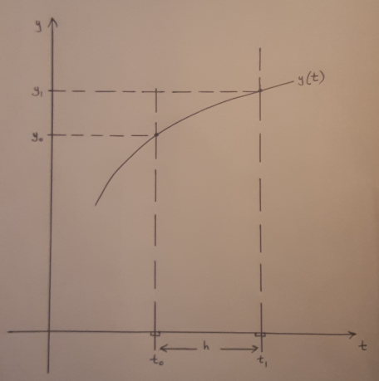

**Figure 10 : The Template for the Integration Methods**

This simplest method is then developed intuitively until the Runge-Kutta methods generalise the intuitive approach. Runge-Kutta methods are known as one-step methods. The sections after Runge-Kutta methods deal with multistep methods where a number of already computed values are used to extrapolate to one more value. These are called Adams-Bashforth methods. The final method described below is the Adams-Moulton or predictor-corrector method where the errors that occur in extrapolation are reduced by using the value of the derivative at the extrapolated point to “drag” the extrapolated curve down to a more correct value.



## First Step : Euler’s Method

There are two variants of Euler’s method : the forward method and the backward method. Both are easily pictured intuitively and geometrically as in the figures to follow. They can also be derived more formally by a Taylor series expansion as in Y at section X.X.X below or by the more formal method shown in Figure X of section Y.Y.Y below.

#### The Forward Euler Method

The forward Euler method is shown as in figure X. The method just uses the gradient at $(t_{0, }y_{0})$ to extrapolate to $t_{1}$. With a $y(t)$ sloping downward the method will get a value of y that is too high ( $y_{1}^{0}$ in the figure). With a small step size $h$ and a $y(t)$ changing only slowly the method can yield a reasonably accurate result. The method can be used repeatedly to calculate further points but errors will accumulate.

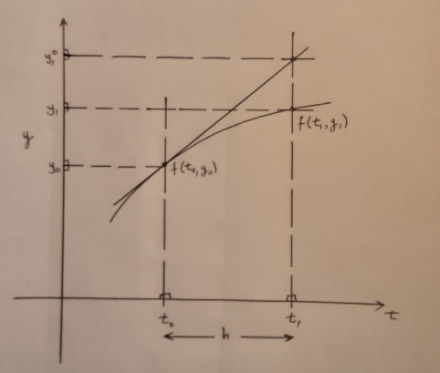

**Figure 11 : Geometry of the Forward Euler Method**

$$y_{1}=y_{0}+hf(t_{0},y_{0})$$

or :

$$y_{1}=y_{0}+hf_{0}$$

or, more generally :

$$y_{n+1}=y_{n}+hf(t_{n},y_{n})$$

$f\left(t_{0},y_{0}\right)$ is the tangent to the curve at $t=t_{0}$. $hf\left(t_{0},y_{0}\right)$ is the increase in $y$ from $y_{0}$ to $y_{1}^{0}$**.** The tangent crosses $t= t_{1}$ at the point shown. $y_{1}^{0}$ is an approximation to the true value $y_{1}$.

#### The Backward Euler Method

The backward Euler method uses the derivative at $y_{n+1}$ to get $y_{n+1}$ itself, which seems at first sight to be an impossible circular equation. Sometimes it is and sometimes it isn’t as will be shown in the linear and non-linear cases below. See [12 Ordinary Differential Equations (Implicit Euler Method) - YouTube](https://www.youtube.com/watch?v=zHmHKjhIGfs) for an analysis of the backward Euler method, with four worked examples.

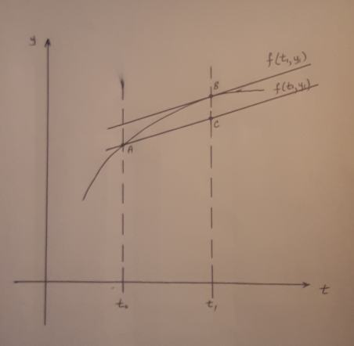

**Figure 12 : Geometry of the Backward Euler Method**

$y_{1 }$ = $y_{0}$ + $hf$ ($t_{1 }$, $y_{1 }$)

or :

$y_{1 }$ = $y_{0}$ + $hf_{1}$

or, more generally :

$y_{n+1}$ = $y_{n}$ + $hf(t_{n+1}$, $y_{n+1}$)

$f(t_{n+1}$, $y_{n+1}$) is the tangent to $y(t)$ at point B. Multiplying this by $h$ and adding to $y_{n}$ means that a line of the same gradient is passed through point A and $y$ at point C is the approximation $y_{n+1}$. The $y$ at point B is the true value.

When the derivative $f(t, y)$ is linear i.e just involves a term $t$ and no higher powers $t^{2 }$ etc the value of $y_{n+1}$ can be solved exactly (though it is still an approximation to the true value). When the derivative is nonlinear, for example there is a $t^{2 }$ term (and nothing else in $t$ the value of $y_{n+1}$ can be derived from finding the roots of the resulting quadratic equation. When the derivative is a general polynomial in t the value of $y_{n+1}$ can still be derived by finding the roots of the polynomial. Additionally, for the general polynomial case, including the quadratic, the roots can be found by a numerical method rather than an analytic method. In fact, for the higher order polynomials (greater then $t^{5})$ a numerical method is necessary as there are no analytic equations giving the roots of (some) polynomials of this order (a very interesting phenomenon that can be explored at [Quintic function - Wikipedia](https://en.wikipedia.org/wiki/Quintic_function) )

The video at [12 Ordinary Differential Equations (Implicit Euler Method) - YouTube](https://www.youtube.com/watch?v=zHmHKjhIGfs) summarises the backward Euler method as in figure 13.

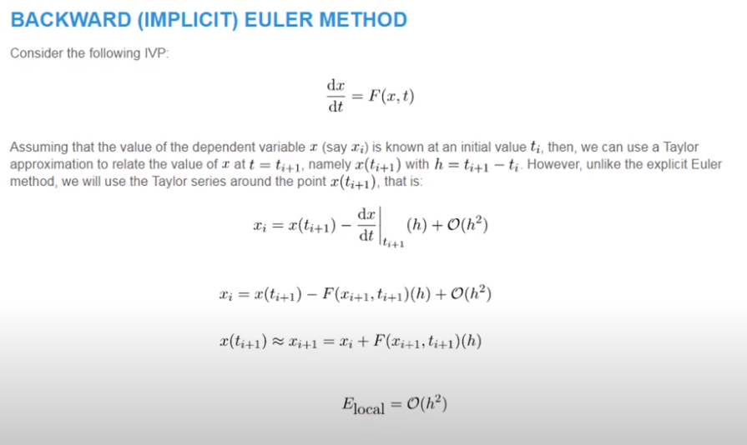

**Figure 13 : Deriving the backward Euler method by using Taylor Series Expansion**

**Source :** [12 Ordinary Differential Equations (Implicit Euler Method) - YouTube](https://www.youtube.com/watch?v=zHmHKjhIGfs)

***The Linear Case***

The video source above takes a simple example $dx/dt = kx$ to show that, in the linear case, $x_{i+1}$ can be derived analytically :

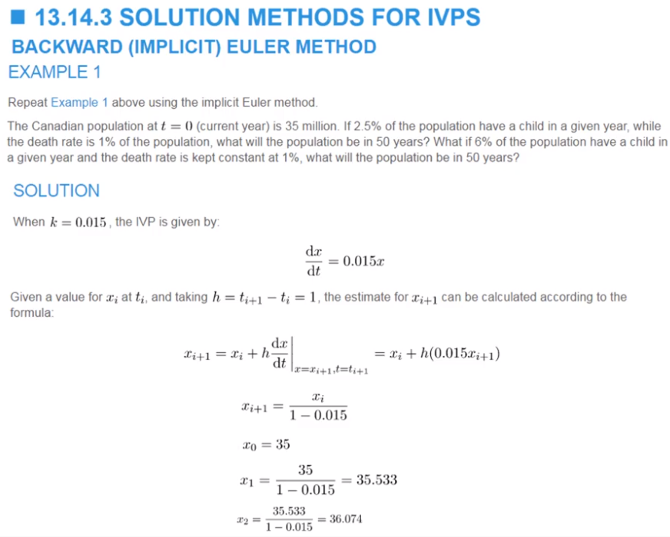

**Figure 14 : A First Linear Backward Euler Method Example**

A second example is more general in that $dc/dt = f(t, c),$ but $c_{i+1}$ can still be solved for analytically :

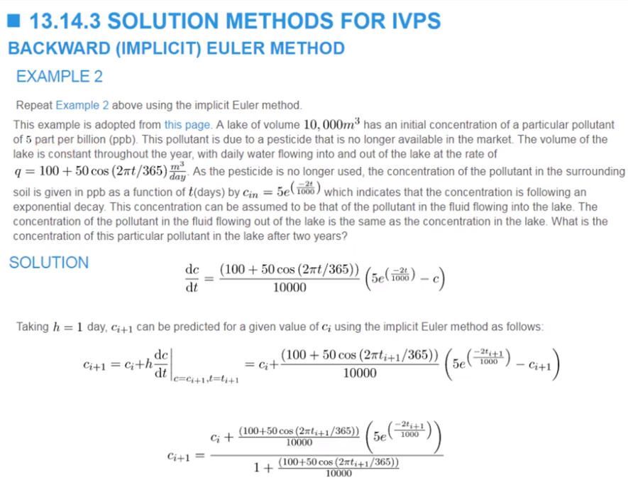

**Figure 15 : A Second Linear Backward Euler Method Example**

***The Nonlinear Case***

A third example shows that the $x_{i+1}$ can again be derived analytically, although the video chooses to use a numerical technique, the Newton-Raphson method, to get the roots of the quadratic.

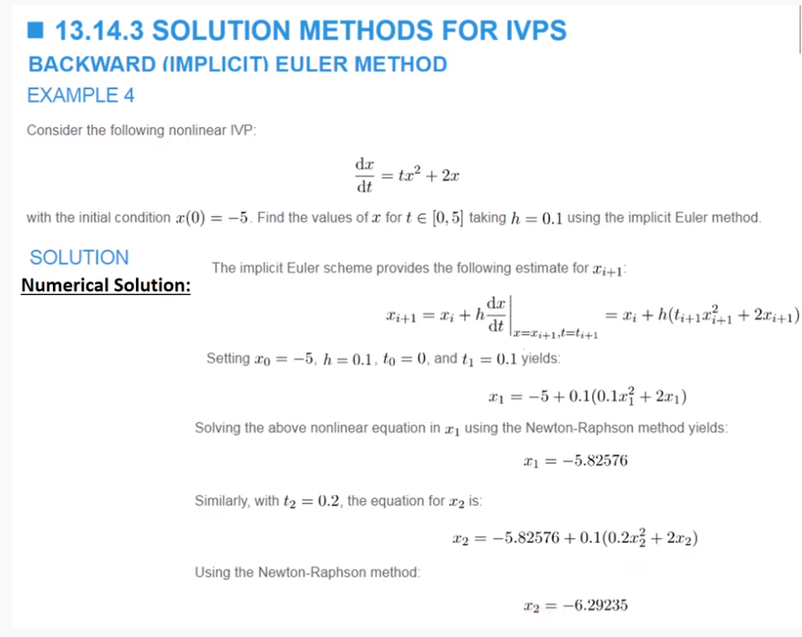

**Figure 16 : A Nonlinear Backward Euler Method Example**

Another method for the nonlinear case is to use the forward Euler method to generate an approximation for $x_{i+1}$ and then to use this approximation to recalculate the $x_{i+1}$ in the backward Euler method. This process can be iterated until two successive iterations are sufficiently close. This is the process used for Heun’s method in the next section 4.3.1.3 and which can be used in the other numerical analysis techniques discussed below.

A technique that calculates $x_{i+1}$ on the left-hand side from $x_{i}$ and derivatives on the right-hand side is called an explicit technique. A technique that calculates $x_{i+1}$ on the left-hand side from $x_{i+1}$ and derivatives on the right-hand side is called an implicit technique.

#### The Heun Method

Heun’s method seems to be a “split the difference” of the forward and backward Euler methods. It can be seen above that (with y(t) chosen as downward-turning to the right) the forward Euler method will get too high a value and the backward Euler method will get too low a value. It is intuitive then to take what is almost the average. This is expressed in the source at figure 17 as :

+ )

where :

, ))

and :

[**k2** is not quite the exact gradient at **tk + h**]

So, in figure 17 below, the approximate average gradient is drawn by bisecting the angle formed by the intersection of the $k_{1}$ and $k_{2}$ gradients. Sliding the average gradient down to cross the curve at $t_{0}$ results in a $z\left(t_{k+1}\right)$ that seems to be very nearly the correct value.

Another way of presenting the method (as given in [Heun's method - Wikipedia](https://en.wikipedia.org/wiki/Heun's_method)) is to say that one first calculates an approximation for $y_{i+1 }$:

$τ_{i+1}$ = $y_{i}$ + hf($t_{i}$, $y_{i}$)

and then uses the approximation in the approximate average :

$y_{i+1 }$ = $y_{i }$ + $\frac{1}{2}h(f(t_{i}$, $y_{i}$) + $f(t_{i+1}$, $τ_{i+1}))$

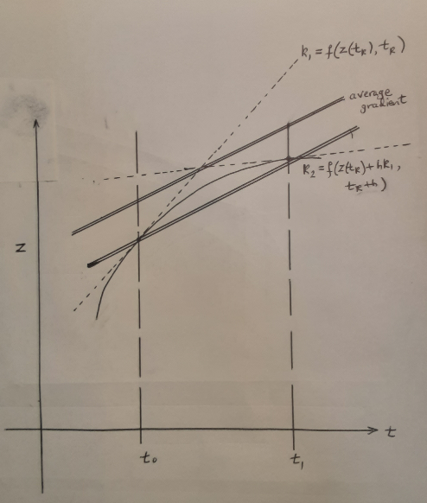

**Figure 17 : The Double Lines Have the Average Gradient**

**Source :**

Figure 18 contains a table comparing the errors that occurred in a particular problem for the Euler method, Heun’s method and a Runge-Kutta 4th order algorithm (this is described in section C). This supports the proposition in this paper about the sequence of Euler, Heun and Euler variants, and Runge-Kutta as being successively more accurate methods.

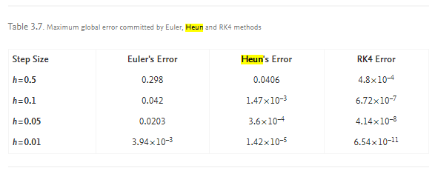

**Figure 18 : Comparing Approximations for Euler, Heun, and Runge-Kutta 4th Order Methods**

**Source :** [Runge-Kutta Method - an overview | ScienceDirect Topics](https://www.sciencedirect.com/topics/mathematics/runge-kutta-method)

#### Variations on the Euler Theme

Heun’s method suggests other possibilities. What about selecting a number of points within $t_{n}$ and $t_{n+1}$ and taking an average of their gradients ? This takes the discussion into the Runge-Kutta methods since the use of intermediate points breaks what one might call the Euler paradigm. The next sections are about Runge-Kutta methods.

### Second Step : Runge-Kutta Methods

Runge-Kutta methods have explicit and implicit forms.

#### Explicit Runge-Kutta Methods

This section on Runge-Kutta methods introduces the subject by appealing to intuition and then defines the methods in the usual more formal way. In the process of doing this it will be shown that the Euler methods and Heun’s method are simple forms of Runge-Kutta methods.

The intuitive approach has already been used in the description of Heun’s method above : the average of the gradients at $y_{n}$ and $y_{n+1}$ is used on the intuition that this must produce a better result. But what if one chooses a point or points between $y_{n}$ and $y_{n+1}$ and used some suitable weighting of the corresponding gradients? Could this produce even better approximations ? The article at [Runge–Kutta methods - Wikipedia](https://en.wikipedia.org/wiki/Runge%E2%80%93Kutta_methods) describes this procedure in a straightforward noncomplicating way (other articles sometimes introduce the details and formalism that only professional mathematicians might use). The article starts with the most well-known Runge-Kutta method, the fourth order method, where :

$y_{n+1}$ = $y_{n}$ + $\frac{1}{6}h(k_{1}$ + 2 $k_{2}$ + 2 $k_{3}$ + $k_{4}$)  
  
and :

$k_{1}$ = $f(t_{n}$, $y_{n}$)

$k_{2}$ = $f(t_{n}+h/2, y_{n}$ + $h(k_{1}/2))$

$k_{3}$ = $f(t_{n}$ $+ h/2,$ $y_{n}$ + $h(k_{2}/2))$

$k_{4}$ = $f(t_{n}$ $+ h,$ $y_{n}$ + ${hk}_{3}$)

The algorithm can be pictured as in figure 19 below.



**Figure 19 : Picturing the Runge-Kutta 4th Order Method**

**Source :** [Runge–Kutta methods - Wikipedia](https://en.wikipedia.org/wiki/Runge%E2%80%93Kutta_methods)

The method takes an average of four gradients, one at each end and two in the middle of the two points. $k_{3}$ obviously compensates for $k_{2}$ being too low. So, in sum, the method averages the two end points and a notional middle point. The sum of the four weighted gradients must intuitively be divided by 6 in order to get something with a gradient-like value.

The source [Runge–Kutta methods - Wikipedia](https://en.wikipedia.org/wiki/Runge%E2%80%93Kutta_methods) gives the formal definition of Runge-Kutta methods as in figure 20 below.

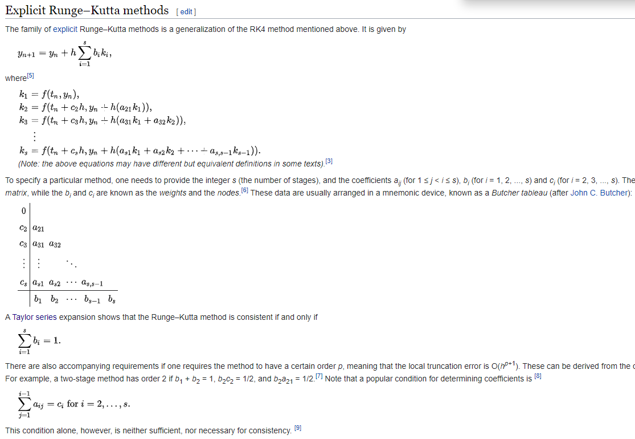

**Figure 20 : Formal Definition of Runge-Kutta Methods**

**Source :** [Runge–Kutta methods - Wikipedia](https://en.wikipedia.org/wiki/Runge%E2%80%93Kutta_methods)

The coefficients can be solved for by making two Taylor series expansions – one for the integrated values ($x$ in the excerpt below) and one for the derivative, the first in one dimension, the second in two dimensions. The excerpt below derives the coefficients for a second order method. The Wikipedia article above derives the coefficients for the fourth order method.

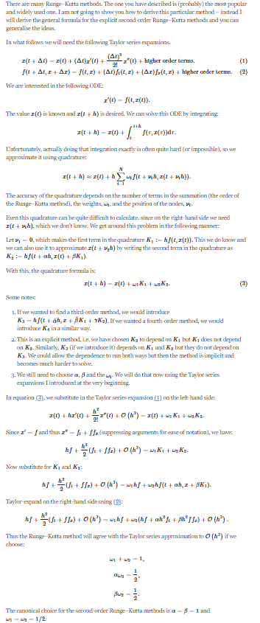

**Figure 21 : Derivation of the Coefficients of a 2nd Order Runge-Kutta Method**

**Source :** [ordinary differential equations - Explanation and proof of the 4th order Runge-Kutta method - Mathematics Stack Exchange](https://math.stackexchange.com/questions/528856/explanation-and-proof-of-the-4th-order-runge-kutta-method)

#### Implicit Runge-Kutta Methods

The section on Euler’s method above described the forward Euler method and the backward Euler method. It was shown that the backward Euler method is an implicit method, as defined in section 4.3.1.2. The forward and backward methods can be combined : the forward method can be used to get an initial value for and this value can then be used in the backward method to get an improved also as described in section 4.3.1.2.

Runge-Kutta methods also have an implicit form as well as the explicit form, as shown in figure 22 below.

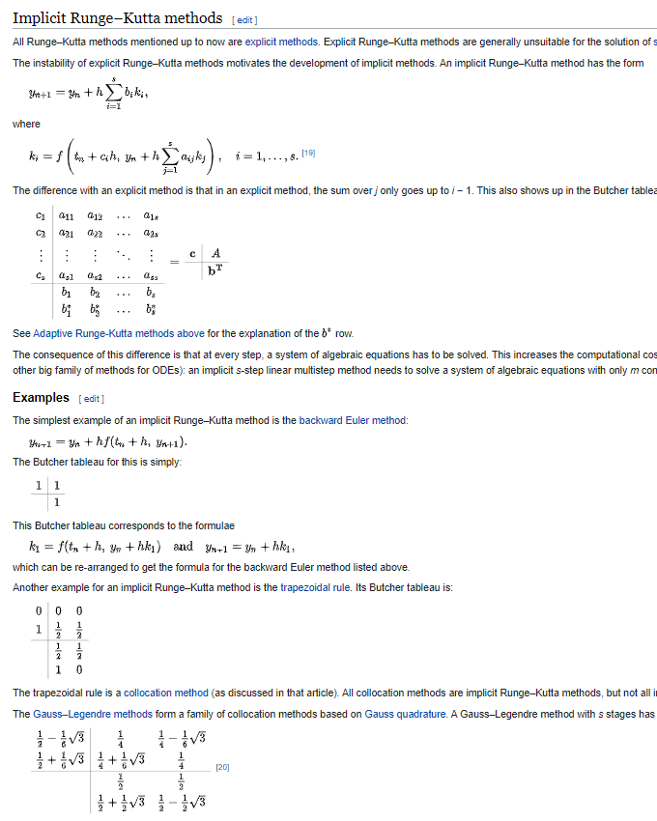

**Figure 22 : Implicit Runge-Kutta Methods**

**Source :** [**Runge–Kutta methods - Wikipedia**](https://en.wikipedia.org/wiki/Runge%E2%80%93Kutta_methods#Implicit_Runge%E2%80%93Kutta_methods)

#### Guassian Quadrature

More needed here

[**https://www.youtube.com/watch?v=Hu6yqs0R7GA**](https://www.youtube.com/watch?v=Hu6yqs0R7GA)

### Third Step : Adams-Bashforth Methods

The video referenced by Figure 23 below shows the usual formulation of a simple ordinary differential equation and a boundary value. The $y’$ is the derivative $dy/dx$, a function of $x$ and $y$. The problem assumes that one value of $y$ is known : for $x= x_{0}$, $y$ is known and is $y(x_{0})$ or $y_{0}$. This is the boundary value.

The video develops the idea that the $(n+1)th$ value of $y$, $y_{n+1}$, can be obtained from a number of previous, known $y$ values by passing an interpolating polynomial through the known values and, essentially, extrapolating that polynomial to $x_{n+1}$ The method is therefore a multistep method in contrast to the Runge-Kutta methods which are single-step methods. Additionally, the methods introduced here work by the use of interpolating polynomials instead of series summation and Gaussian quadrature.

An initial sequence of known values can in fact be constructed, perhaps by approximation with Euler’s method (shown in the video) using $y_{0}$. The boundary value is used to start the sequence off (see 10.30 in the video). These two values can then be used to get a third value, $y_{2}$, and so on. The initial sequence could alternatively be constructed with repeated application of one of the Runge-Kutta methods.

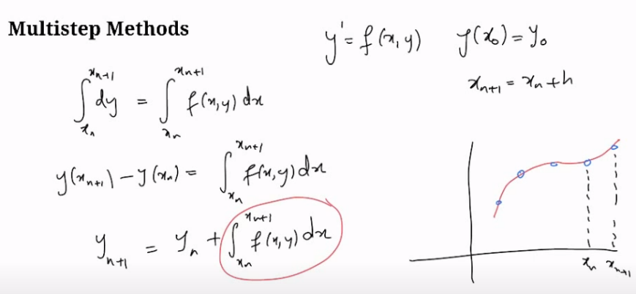

**Figure 23 : Numerical Integration of an Ordinary Differential Equation**

Source : [Numerical methods for ODEs - Multistep methods - Adams Bashforth - YouTube](https://www.youtube.com/watch?v=fp6n7x55tkQ)

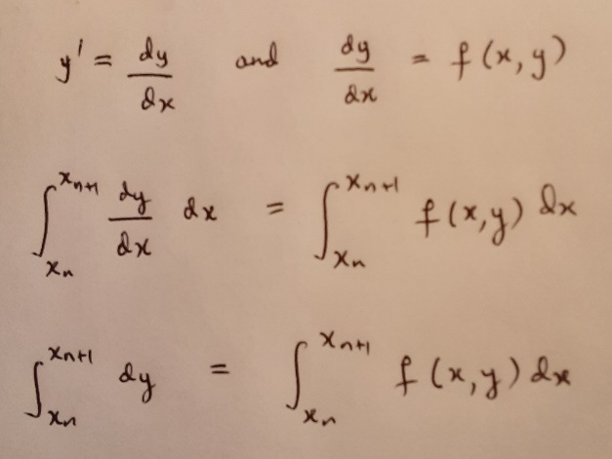

**Figure 24 : The Step to the $dy$ Integral**

The video above develops the discussion essentially only to the second order Adams Bashforth equation. The derivation of this second order equation is shown in figure 4 below, where $h$ is the step size of the method i.e the distance between any two $x$ values (constant step size is assumed). The equation is second order because it develops a third value from two previous values. The minimum polynomial required is a straight line, since there are two points. A quadratic could be passed through the two points but there is not enough information to determine what the quadratic would be. That is, an infinite number of quadratics could fit the two points.

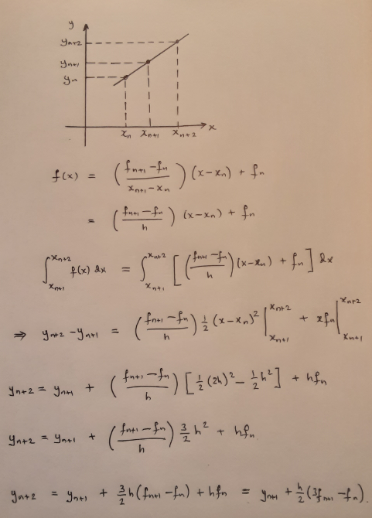

**Figure 25 : The 2nd Order Adams-Bashforth Equation**

The video referred to in figure 23 shows the general case. In the general case a polynomial is fitted through the known points of the curve of the derivative and then the polynomial is integrated. So, if the known points are ($x_{n}$, $y_{n}$), ($x_{n-1}$, $y_{n-1}$), ($x_{n-2}$, $y_{n-2}$), ……. The video shows the calculation of $y_{n+1}$ **.**

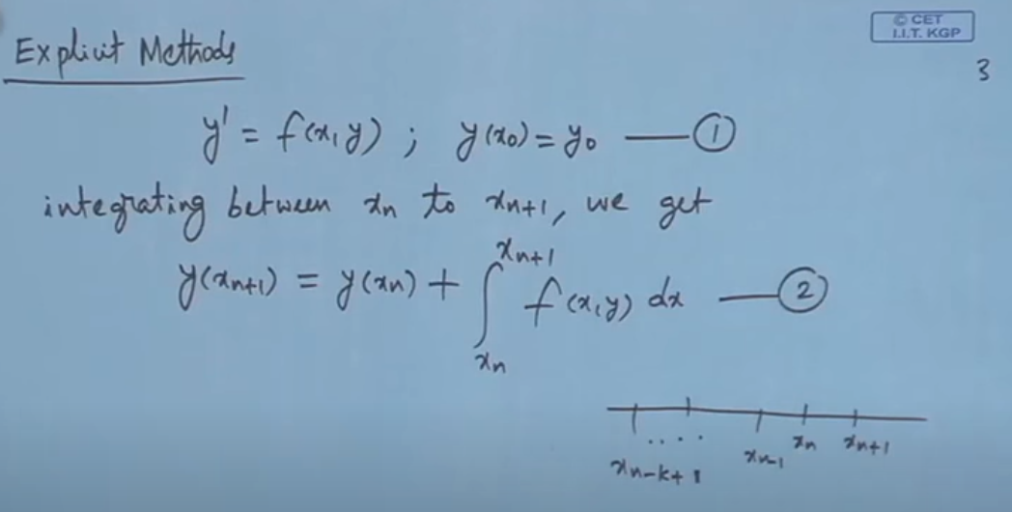

**Figure 26 : Using a set of known points (xn, yn), (xn-1, yn-1), (xn-2, yn-2)….**

**Source :** [Mod-09 Lec-09 Multi-Step Methods (Explicit) - YouTube](https://www.youtube.com/watch?v=cIgn3JCPyOA)

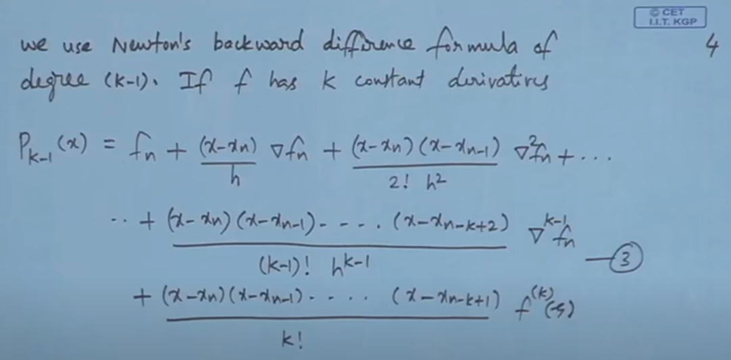

**Figure 27 : Use of the Newton Interpolation Polynomial for Numerical Integration**

**Source :** [Mod-09 Lec-09 Multi-Step Methods (Explicit) - YouTube](https://www.youtube.com/watch?v=cIgn3JCPyOA)

In Figure 27 ∇f**n** is the backward difference operator, defined in the two following difference tables :

**xn-2** **fn-2**

**fn-1** – **fn-2**

**xn-1** **fn-1** (**fn** – **fn-1**) – (**fn-1** – **fn-2**)

**fn** – **fn-1**

**xn** **fn**

or, using the ∇f**n** symbol :

**xn-2** **fn-2**

∇f**n-1**

**xn-1** **fn-1** ∇**2**f**n**

∇f**n**

**xn** **fn**

The form of the polynomial is such that when $x = x_{n}$ the value is $f_{n}$, which is correct, when $x = x_{n-1}$ the value is $f_{n-1}$ which is correct, and so on.

Using the integration shown in the video above one can derive the following higher order Adams-Bashforth equations shown in Figure 28. The video concentrates on the 4th order method (see @45.00).

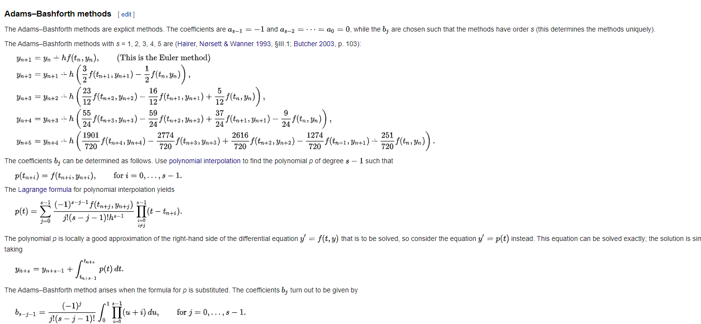

**Figure 28 : Adams-Bashforth Equations up to Fifth Order**

**Source :** [Linear multistep method - Wikipedia](https://en.wikipedia.org/wiki/Linear_multistep_method)

Note that, for each of the five equations above, the average addition is of the order of $hy$ i.e when the fractions are added the sum is 1.

There are, in fact, two different forms for the interpolating polynomials : the Newton form as used above and the Lagrange form.

**Semi-Quantitative Exploration of 2nd Order Adams-Bashforth Properties**

Figure 29 below looks at three examples, two of which can be called “pathological” although they demonstrate potential pitfalls. The solid curve is the supposed integrated solution $y(x)$ whose gradient at any point is the differential equation under consideration. The figure also pictures what is actually happening during evaluation of the equations.

In the first example, involving points A and B, the equations may completely miss a feature of $y(x).$ Applying the Euler method to get $y_{1}$ from $y_{0}$:

$y_{1}$ = $y_{0}$ + $h{y'}_{0}$

Using point A one can see qualitatively that the gradient at A with a step size of about 20 will predict a $y_{1}$ at or near point B. Thus, when the calculation of $y_{2}$ and successive points takes place, the rise in the curve peaking at $x=20$ will be completely missed.

In the second example, using the points labelled $y_{0}$ and $y_{1}$ in the figure, the Euler method may lead to y**1** being on the downside of the peak, around $y= 4$. The algorithm here looks as though it will not be able to recover since the gradient has hugely changed. Given a step size of 12, the gradient at $y_{0}$ is about +2/12 and at $y_{1}$ it is about -4/9. So the 2nd order Adams-Bashforth equation :

$y_{2}$**= $y_{1}$** + $(h/2)(3f_{1}$– $f_{0}$)

gives :

$$y_{2} = 4 + 6 (-12/9 – 1/6) = -5$$

The prediction puts $y_{2}$ at -5, way below the actual $y(x).$

The third example, involving points C, D and E, is something like the normal case. Application of the Euler method starting at $y_{0}$ with a step size of 3 gives point E at about (14, 2.5) and with a gradient of about 6/13. The correct point is at C so the error is easily seen. However, when the 2nd order equation is applied, we get :

$y_{2}$ = 2.5 + (3/2) (3*(6/13) – 1/6) = about 4.25

which is quite near the correct point D. So the algorithm is correcting itself.

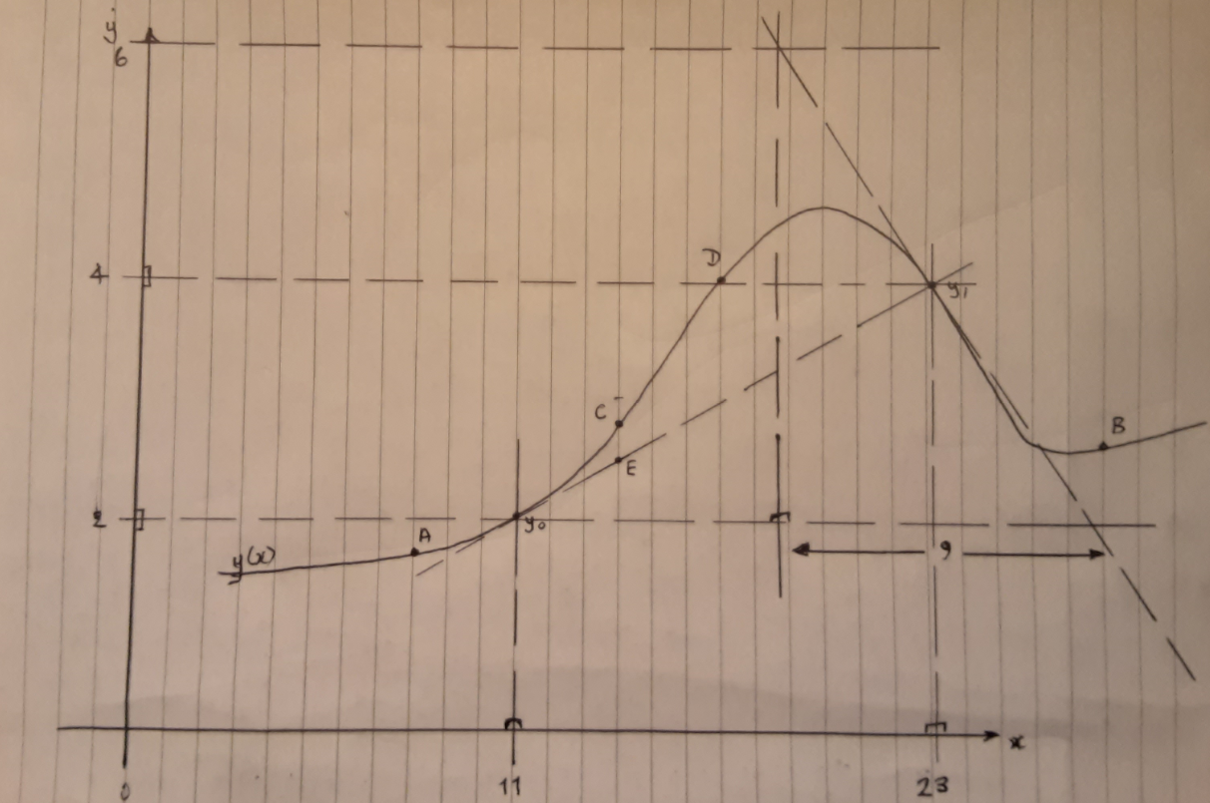

**Figure 29 : Experimenting with “Pathological” Examples**

Below in figure 30 two graphs taken from the cited source demonstrate the influence of step size. A step size of 0.02 for this example delivers a fairly poor approximation to the real curve. However, a step size of 0.01 delivers a fairly good approximation (in qualitative terms).

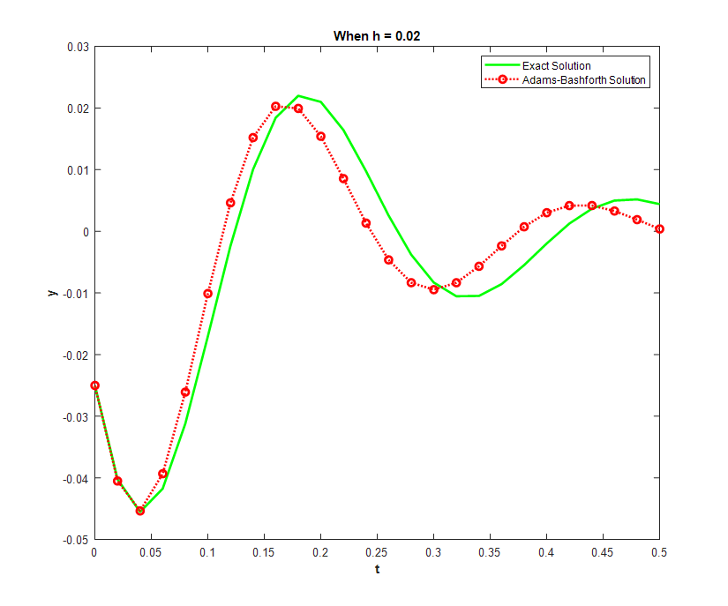 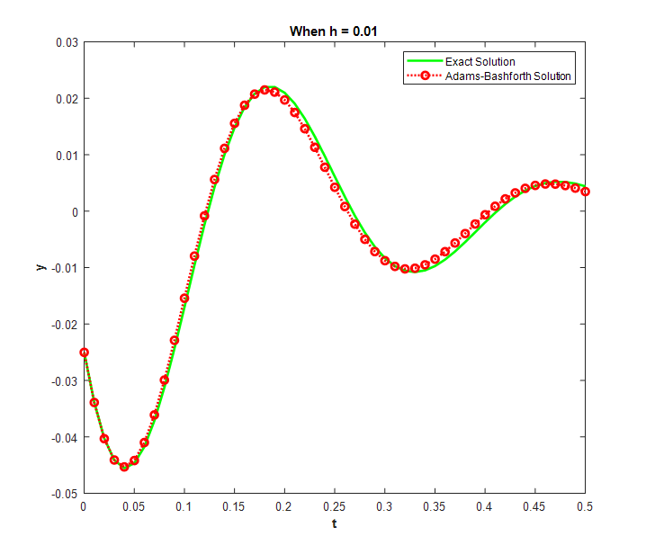

**Figure 30 : Effect of Step Size (an example)**

**Source :** [Everything Modelling and Simulation: Adams-Bashforth Method with RK2 (modellingsimulation.com)](https://www.modellingsimulation.com/search/label/Adams-Bashforth%20Method%20with%20RK2)

### Fourth Step : Adams-Moulton Methods

The Adams-Bashforth technique gives an approximation to the correct value. But how can we know that the approximation is useful and that it has not, in fact, diverged significantly from the correct solution ? After all, the technique is essentially extrapolation and the extrapolation will start to diverge. A way is needed to “drag” the extrapolated values back to the actual curve. In fact, this issue has already been described in the backward Euler, Heun, and Runge-Kutta methods : the Adams-Bashforth (AB) explict algorithms have implicit equivalents called Adams-Moulton (AM) methods. Together, in pairs, these apply a “predictor-corrector” method : an explicit AB method produces an initial approximation which is then used in the corresponding AM method to improve the value. It is this corrector stage that “drags” the approximated value back to the derivative curve. See figure 31 below.

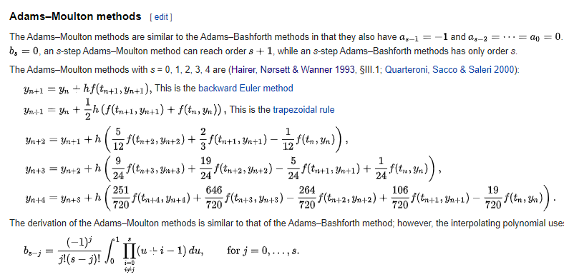

**Figure 31 : Adams-Moulton Implicit Methods**

**Source :** [Linear multistep method - Wikipedia](https://en.wikipedia.org/wiki/Linear_multistep_method)

## The Calculation of Error Bounds in Numerical Integration

In his book “For the Love of Physics” Walter Lewin says “

### Error Bounds for Non-Taylor Series Integrations

## Difference Tables

Difference tables are involved in three areas that have been explored in this paper so far, whether explicitly or implicitly. This section looks at those three areas with a focus on difference tables.

### Difference Tables and Adams-Bashforth Methods

The Adams-Bashforth and Adams-Moulton methods do not use difference tables explicitly but there is a difference table implicit in the methods. The methods start with a presumed known set of $x$ and $y$ values plus the derivatives at those points. A polynomial is then fitted through the values of the derivatives at the known points and the polynomial is integrated to get the next $y$ value.

### Standard Extrapolation

In what one might call standard extrapolation a difference table is used to intuitively calculate the next $y$ value, as in the example in figure 33 :

$x_{0}$ $y_{0}$

$f_{0}^{1}$

$x_{1}$ $y_{1}$ $f_{1}^{1}$

$f_{0}^{2}$ $f_{2}^{1}$

$x_{2}$ $y_{2}$ $f_{1}^{2}$ $f_{3}^{1}$

$f_{0}^{3}$ $f_{2}^{2}$

$x_{3}$ $y_{3}$ $f_{1}^{3}$ $f_{3}^{2}$

$f_{0}^{4}$ $f_{2}^{3}$

$x_{4}$ $y_{4}$ $f_{1}^{4}$

$f_{0}^{5}$

$x_{5}$ $y_{5}$

**Figure 33 : A Difference Table – Calculate $y_{5}$**

$y_{5}$ can be calculated by assuming a value $f_{3}^{2}$ equal to $f_{3}^{1}$ and then calculating the differences down the bottom of the table until $y_{5}$ is reached, as follows :

$y_{5}$ = $y_{4}$ + $f_{0}^{5}$

$f_{0}^{5}$ = $f_{0}^{4}$ + $f_{1}^{4}$

$f_{1}^{4}$ = $f_{1}^{3}$ + $f_{2}^{3}$

$f_{2}^{3}$ = $f_{2}^{2}$ + $f_{3}^{2}$

$f_{3}^{2}$ = $f_{3}^{1}$

And, in fact, if all the differences are reduced back to the $y$ values, one obtains :

$y_{5}$ = ${5y}_{4}$- ${10y}_{3}$ + ${10y}_{2}$- ${5y}_{1}$ + $y_{0}$

How can the Adams-Bashforth method and the standard extrapolation methods both give an answer to the same problem (though the former is probably better than the latter) ? If one takes the equation for $y_{5}$ above it can be factored into :

$y_{5}$ = $y_{4}$ + $4(y_{4}- y_{3})$- ${6(y}_{3}-$ $y_{2})$ + ${4(y}_{2}-$ $y_{1})$- ${(y}_{1}- y_{0})$

On the basis that, very approximately $(y_{4}- y_{3})/h$ is $y_{4}^{'}$ and similarly for the other terms then one has :

$y_{5}$ = $y_{4}$ + $4hy_{4}^{'}$- $6hy_{3}^{'}$ + $4hy_{2}^{'}$- $hy_{1}^{'}$

which is similar in form to the 4th order Adams-Bashforth equation above. The coefficients sum to 1 as they also do in the Adams-Bashforth method. Their magnitudes are also similar to the magnitudes of the Adams-Bashforth method. This provides a link (rather tenuous) between the two methods.

The table on which the Adams-Bashforth and Adams-Moulton methods are based is a difference table in the derivatives :

$x_{0}$ $y_{0}$ $y_{0}^{'}$

$y_{1}^{'}$- $y_{0}^{'}$

$x_{1}$ $y_{1}$ $y_{1}^{'}$

$y_{2}^{'}$- $y_{1}^{'}$

$x_{2}$ $y_{2}$ $y_{2}^{'}$

$y_{3}^{'}$- $y_{2}^{'}$

$x_{3}$ $y_{3}$ $y_{3}^{'}$

$y_{4}^{'}$- $y_{3}^{'}$

$x_{4}$ $y_{4}$ $y_{4}^{'}$

$x_{5}$ $y_{5}$

**Figure 34 : A Difference Table In the Derivatives**

The most that can be achieved by a non-integration method is to get an approximation for $y_{5}^{'}$ by using the differences and then use Euler’s or Heun’s method to get a value for $y_{5}$.

### An Example Ordinary Differential Equation

Below is an example equation that can be used to explore different methods.

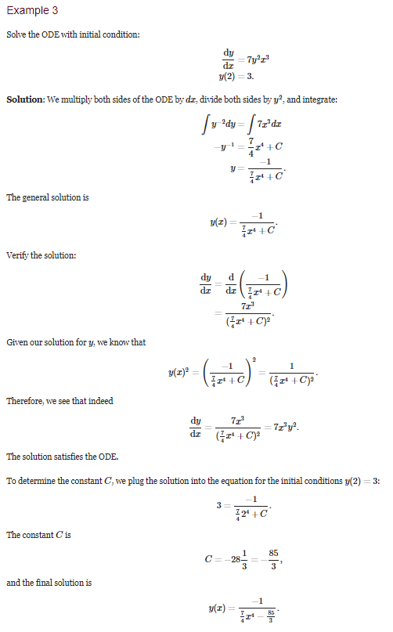

**Figure 35 : An Example Ordinary Differential Equation**

**Source :** [Ordinary differential equation examples - Math Insight](https://mathinsight.org/ordinary_differential_equation_introduction_examples)

### Schwarszchild’s Use of Difference Tables

As described in Part I of these papers…….

How good/bad is extrapolation from a difference table compared with A-M method ?

**Further References**

[Taylor & Maclaurin polynomials intro (part 1) | Series | AP Calculus BC | Khan Academy - YouTube](https://www.youtube.com/watch?v=epgwuzzDHsQ)

# **COUPLED DIFFERENTIAL EQUATIONS**



## Definition of Coupled Equations

By “coupled” is meant that there are a number of linked equations of the form that has been the subject of this paper :

$\frac{dy}{dx}$ = $f(x, y\left(x\right))$ with $y\left(x_{0}\right)= y_{0}$

So, for example, a system of two coupled equations could be :

$\frac{dy}{dx}$ = $f(x, y\left(x\right), z(x))$ with $y\left(x_{0}\right)= y_{0}$

$\frac{dz}{dx}$ = $g(x, y\left(x\right), z(x))$ with $z\left(x_{0}\right)= z_{0}$

Looking ahead to Part III of this set of three papers on the calculation of stellar structure, the four equations describing the stellar structure of main sequence stars are the hydrostatic pressure, mass fraction, luminosity and temperature equations :

$$\frac{dP}{dr} = - ρ(P, T) \frac{GM_{r}}{r^{2}}$$

$$\frac{dM_{r}}{dr} = 4πr^{2}ρ(P, T)$$

$$\frac{dL_{r}}{dr} = 4πr^{2}ρ(P, T)Ɛ$$

$$\frac{dT}{dr} = \frac{-3}{4ac}.\frac{χρ(P, T)}{T^{3}}.\frac{L_{r}}{4πr^{2}}$$

$$\frac{dT}{dr} =(1-\frac{1}{γ})\frac{T}{P}\frac{dP}{dr}$$

where $ρ$, the density, is a function of $P and T$. The first temperature equation is for radiative heat transfer. It is replaced with the second equation for convective heat transfer. So these, in the style set out above, have the form :

$$\frac{dP}{dr} = f_{1}(r^{2}, {P\left(r\right), M}_{r}\left(r\right), T(r))$$

$$\frac{dM_{r}}{dr} = f_{2}(r^{2}, P\left(r\right), T(r))$$

$$\frac{dL_{r}}{dr} =f_{3}(r^{2}, P\left(r\right), T(r))$$

$$\frac{dT}{dr} = f_{4}(r^{2}, {P\left(r\right), L}_{r}\left(r\right), T(r))$$

If expressions for these equations are found that allow the use of Adams-Bashforth methods, for example, then the evaluation of new values of $P, T,$ $M_{r}$, $L_{r}, T$ means that these values can be used to calculate new values for the derivatives that can then be put into the ***next*** cycle of $P, T,$ $M_{r}$, $L_{r}, T$. Section 2.1 of Part III of these papers develops this idea further.

**NOTE TO ME :**

**This is the structure of the argument and what I want to do :**

1. **With a constant density approximation the main 4 equations can be analytically integrated but it must be remembered that an approximation is involved so the equations should be used for only a small amount when integrating out from the centre.**
2. **The 4 integrated equations can be converted into Schwarszchild’s second transformation variables but why not just stay with the physical r unit ?**
3. **The integrated equations vary with r (or x*) only which means that their right-hand sides are decoupled.**
4. **An AM algorithm can take over from the initial outward solution. This will require values for the derivatives at points x*. At this point the p*, q*, f*, t* values are distributed across to the other equations (to get the derivatives).**
5. **There is also what one might call a linear density approximation. This can also give analytic solutions. These can also presumably be converted to p*, q*, f*, t* form.**
6. **Is it possible to stay with the untransformed (physical) variables and use numerical methods directly on the initial 4 equations ? At first sight we could :**

* **Use a Taylor series expansion about the centre**
* **Use a Heun algorithm**
* **Use an RK algorithm**

1. **Don’t worry too much about which integration scheme to adopt. Getting started is better than trying for perfection.**